THE TRAGEDY OF FLIGHT

A COMPREHENSIVE CRASH ANALYSIS



1. **INTRODUCTION**

An airplane crash analysis is a detailed investigation into the causes of an aviation accident. The goal of an airplane crash analysis is to identify any factors that contributed to the accident, with the ultimate goal of improving safety and preventing future accidents. The process of conducting an airplane crash analysis typically involves the collection and analysis of a wide range of data, including information about the aircraft and its system, the operators, and any other relevant factors.

This data is typically collected from Kaggle. Once the data has been collected, it is analysed through tableau, to identify any potential causes of the accident. The results of an airplane crash are typically published in a report, which may include recommendations for improving safety and preventing similar accidents in the future. These recommendations may be implemented by the relevant authorities or industry organizations.

1. **PROBLEM DEFINITION ANSD DESIGN THINKING**

EMPATHY MAP

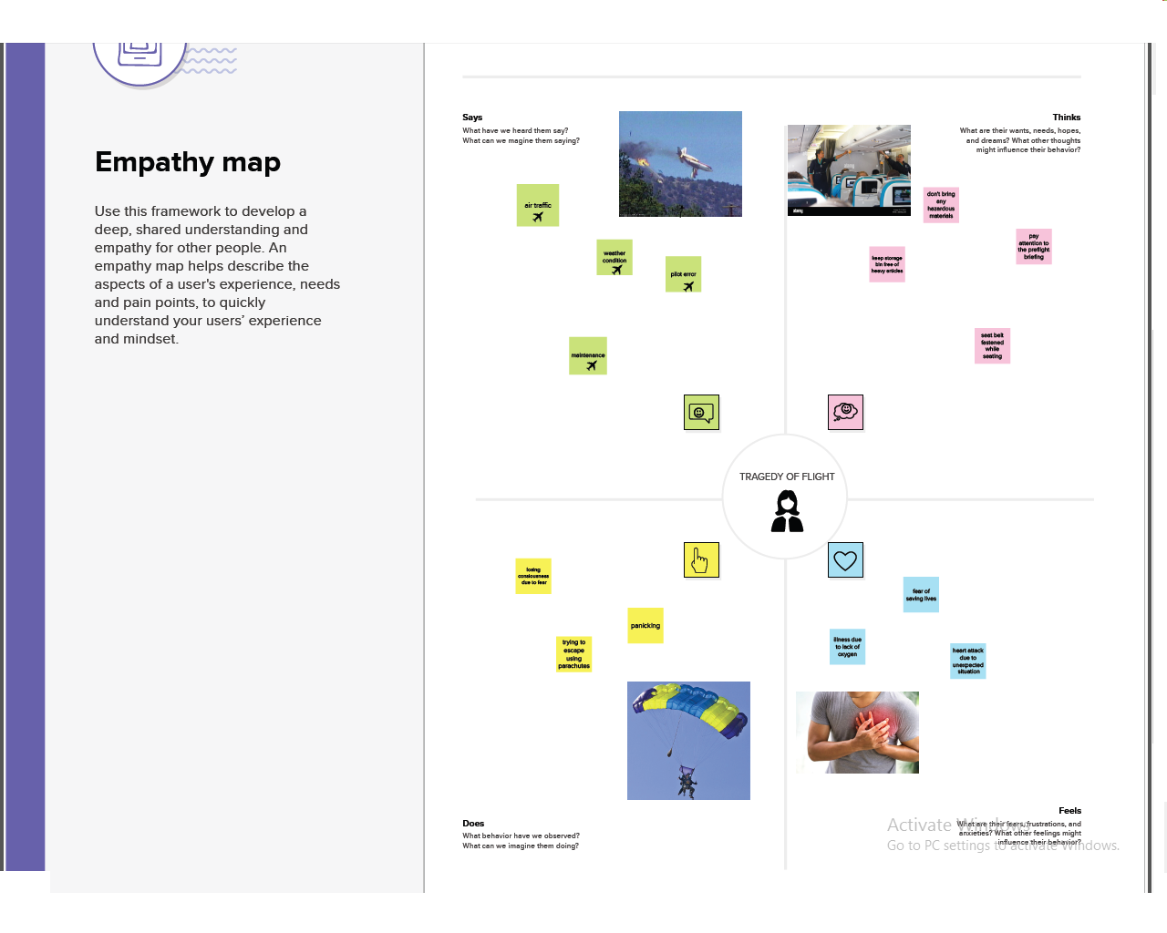

IDEATION AND BRAINSTORMING MAP

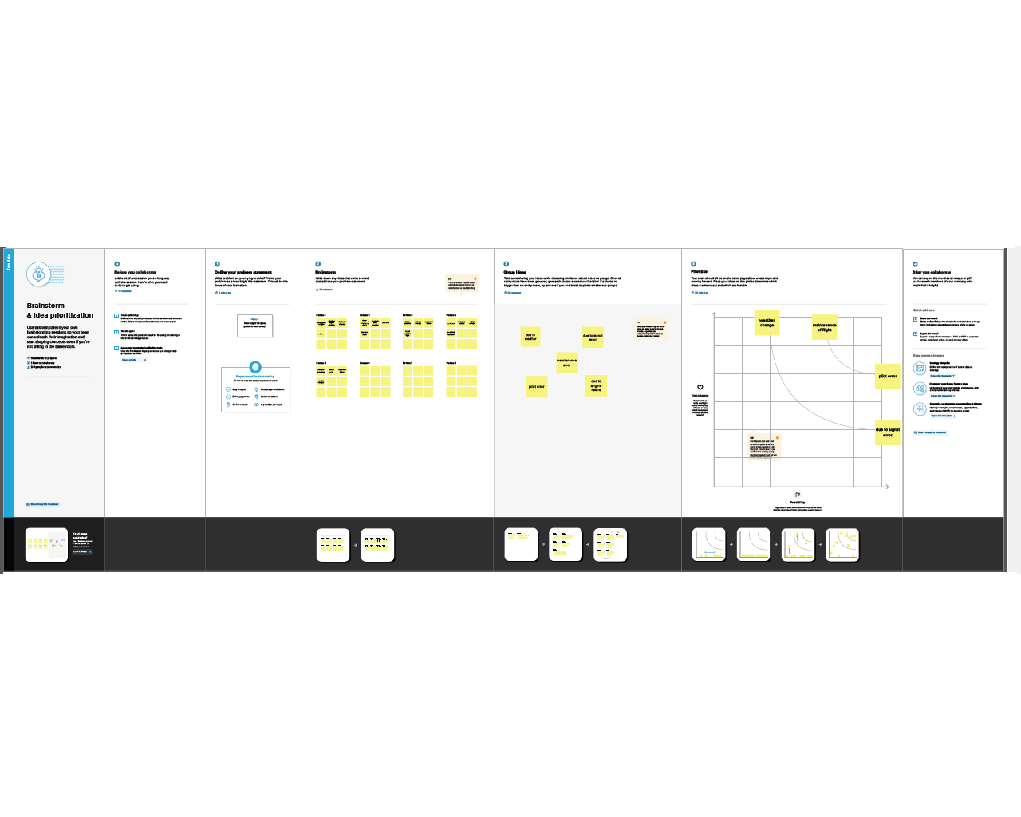

1. RESULT

DASHBOARD 1

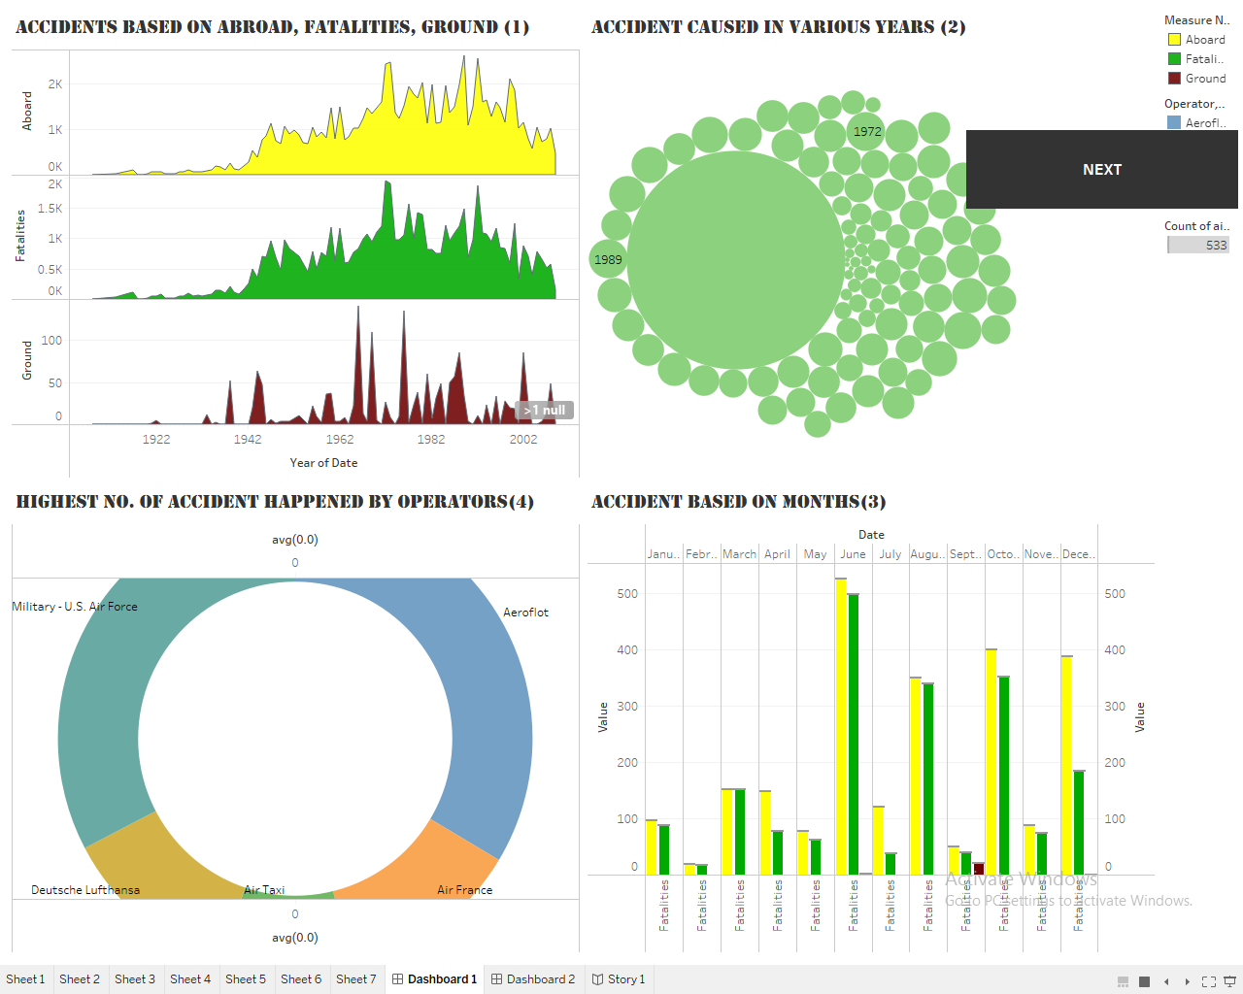

DASHBOARD 2

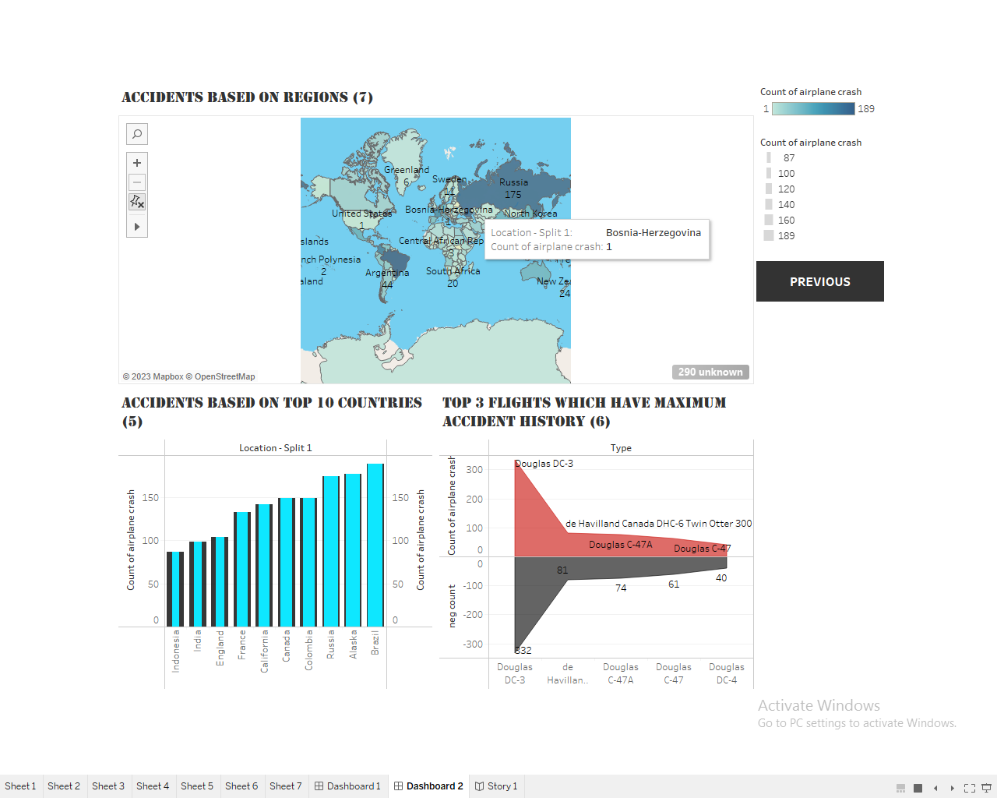

1. ADVANTAGES OF AIR CRASH ANALYSIS

The objective of accident analysis is to prevent accidents in the future. In drawing up the aircraft accident analysis form and the accompanying definitions had in mind the frequency rate of accidents from the various causes, the logical lines along which studies should be conducted, and the ease with which these studies can be made from this chart. It is recognized that to make a detailed study of accidents due to any one cause a further subdivision may be necessary. However, if all accidents are classified according to this chart the major causes can be easily determined and further investigation can be readily carried out for the purpose of eliminating these causes.

It was also recognized, in working out this chart, that the division of immediate causes between personnel and materiel as set forth in the chart and definitions was more or less arbitrary, since. all defects of aircraft can in the last analysis be attributed to errors of personnel, whether in operation, inspection, maintenance, manufacture; or design Since the purposes of the accident study seemed to be best served by drawing attention to defects of materiel, even though traceable ultimately to personnel errors, the line between personnel and materiel in the immediate causes was drawn at the operating personnel of the aircraft. In other words, under the main heading "Personnel" there are included only those accidents for which personnel engaged in operating the aircraft are responsible. Accidents due to materiel failure are classified under "Materiel" even though personnel charged with design, construction, or operation may be held responsible for the failure. Errors due to personnel other than those immediately accessory to the operation of the aircraft are shown in the "Underlying causes" or "data analysis," as set forth hereinafter, rather than in the main headings of immediate causes.

1. APPLICATIONS

Aviation accident analysis is performed to determine the cause of errors once an accident has happened. In the modern aviation industry, it is also used to analyse a database of past accidents in order to prevent an accident from happening. Many models have been used not only for the accident investigation but also for educational purpose.

Per the Convention on International Civil Aviation, if an aircraft of a contracting State has an accident or incident in another contracting State, the State where the accident occurs will institute an inquiry. The Convention defines the rights and responsibilities of the states.

ICAO Annex 13—Aircraft Accident and Incident Investigation—defines which States may participate in an investigation, for example: the States of Occurrence, Registry, Operator, Design and Manufacture.

In the aviation industry, human error is the major cause of accidents. About 38% of 329 major airline crashes, 74% of 1627 commuter/air taxi crashes, and 85% of 27935 general aviation crashes were related to pilot error.[3] The Swiss cheese model is an accident causation model which analyse the accident more from the human factor aspect.

1. CONCLUSION

This analysis features the increase in accidents involving private small aircraft and gliders. Accidents are often caused by pilots who have certain flight experience.

This analysis helps to understand accidents based on months that happened is a certain year (1972), accidents that happened in all these years and it is found that 1972 has the large number of air accidents. And it is also found that Brazil is top country which has 189 number of accident cases and next to it is Russia has 175 number of accidents.

Also we can find the flights which the most accidents in the air crash history. Military of US caused more accidents. And knowing these we can try to avoid further future accidents. The prediction of the system helps the user in taking the necessary precautions to prevent the mishap or any airplane crashes. The administration department thus becomes aware of the possible difficulties and hurdles that might come along the way. As a result, the elementary steps taken will help to eradicate any crashes that might occur thus leading to minimize the loss of prop

1. FUTURE SCOPE

With the increase of global civil aviation transportation, more and more researchers pay attention to the analysis of civil aviation accidents. Time series analysis can obtain the variation law in a large amount of data, and there is no research result of aviation accident time series yet. Based on the Mann-Kendall trend analysis and mutation analysis methods, this paper studied the change trend of accidents and casualties in different flight stages of civil aviation and built ARIMA (Autoregressive Integrated Moving Average model) time series analysis model to predict the number of civil aviation accidents and casualties by the long-term data in the world. The number of civil aviation accidents fluctuates generally in the world; from 1942 to 2016, there were two fluctuation periods of civil aviation accidents. The number of global civil aviation casualties from 1942 to 2016 showed a parabola trend of increasing first and then decreasing. The highest number of casualties appeared in 1972, which was 2373; on the different flight stages, the number of accidents was different. In the air route and approach phase, the number of accidents was the most, and the number of casualties was more than other flight phases, accounting for about 50% of the whole flight phase. In addition to the land phase, the number of accidents showed a significant decrease in other flight phases; while the air route and total number of casualties decreased significantly, the number of casualties at other flight phases did not decrease significantly. There were no sudden changes in the number of global civil aviation accidents and approach casualties. The sudden change point of the global civil aviation casualties was 2013, the sudden change point of the air route stage accidents was 1980, the sudden change point of approach stage accidents was 2012, and the sudden change point of air route stage casualties was 2006. According to the ARIMA model, the numbers of global civil aviation accidents and casualties were predicted to 2025. Through time series research, we have explored the variation law in the historical data of long-term aviation accidents and predicted the possible changes of future aviation accidents, providing data reference for aviation safety research.